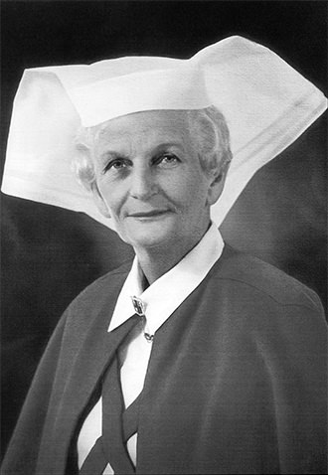
2023 MAVIS
MITCHELL
MEMORIAL
SCHOLARSHIP
Nursing & Midwifery Staff Only - Apply Now!
The Scholarship honours the memory of Mavis J Mitchell who was the first Matron of Western Hospital. The intent of this fund, which commenced in 1990, is aimed at supporting early researchers and service improvements by nurses or midwives across Western Health.
Are you currently undertaking a research project or service improvement to benefit our clients or the community serviced by Western Health or have a great idea and need some funding support? If this is you, then consider applying for the $5,000 Mavis Mitchell Memorial Scholarship Grant which can provide financial assistance to help further your endeavours.

The successful applicant/s will be encouraged to present their outcomes at the annual Research and Best Care Conference.

Applications sent to:  Scholarships Registrar  Education & Learning  Footscray Hospital, Gordon Street Footscray VIC 3011  Email: welearn@wh.org.au | Closing date:  29th September 2023  Applications received after closing date will not be considered.
For further information:
http://www.westernhealth.org.au/EducationandResearch/Education/Pages/Postgraduate-Education.aspx

