=

Public holiday Guide
  - MAINTENANCE
victorian hospital's industrial association – FEB 2024

introduction
The purpose of this Public Holiday Guide is to replace the previous Public Holiday Matrices and summarise the public holiday entitlements afforded to employees under the Maintenance (Victorian Public Health Sector) (Single Interest Employers) Enterprise Agreement 2023 – 2027 (Agreement) for the remaining life of the Agreement until it is replaced.
Members will no longer receive multiple Public Holiday Matrices throughout the year, rather members can use this document to prepare for all public holidays for the remaining life of the Agreement.
VHIA has detailed the known public holidays that occur between the publication date of this Public Holiday and the nominal expiry date of the Agreement, 31August 2027. VHIA will provide updated advice to members closer to that date where the Agreement is anticipated to operate beyond the nominal expiry date.
It is not intended to replace the Agreement or provide an entitlement beyond the Agreement itself.
VHIA encourages members to read the relevant terms of the Agreement alongside this Public Holiday Matrix.

where to find copies of the agreement and other material
VHIA members can access copies of the Agreement and other material (such as Implementation Guides and Salary Circulars) by selecting Maintenance under ‘My Professions’ on your VHIA Website Dashboard.
For more information about accessing the VHIA Website, please contact vhia@vhia.com.au

WHO TO CONTACT FOR MORE INFORMATION
Members are encouraged to direct any queries in relation to this Public Holiday Guide to query@vhia.com.au

working on a public holiday
Relevant Clause
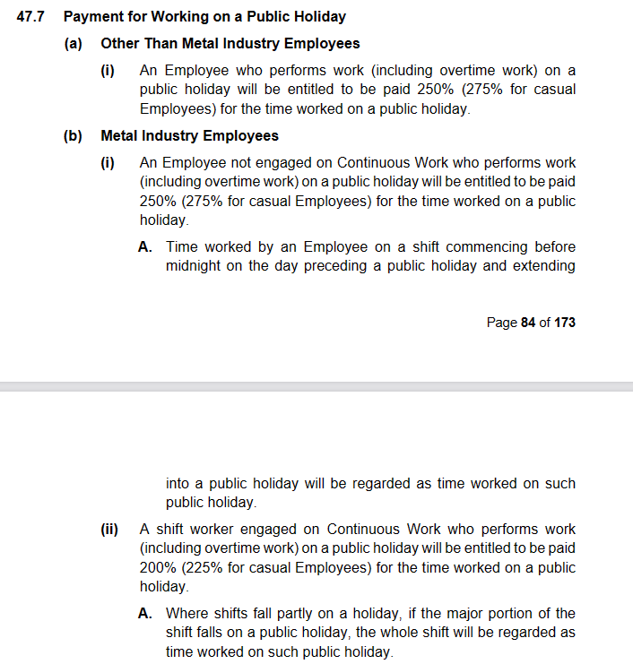

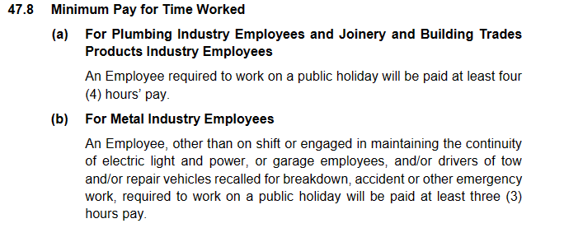

not working on a public holiday – FULL TIME
Relevant Clause
Note: The definition of Actual Day and Other Day can be found summarised below under Additional Rules – Public Holidays falling on a Weekend
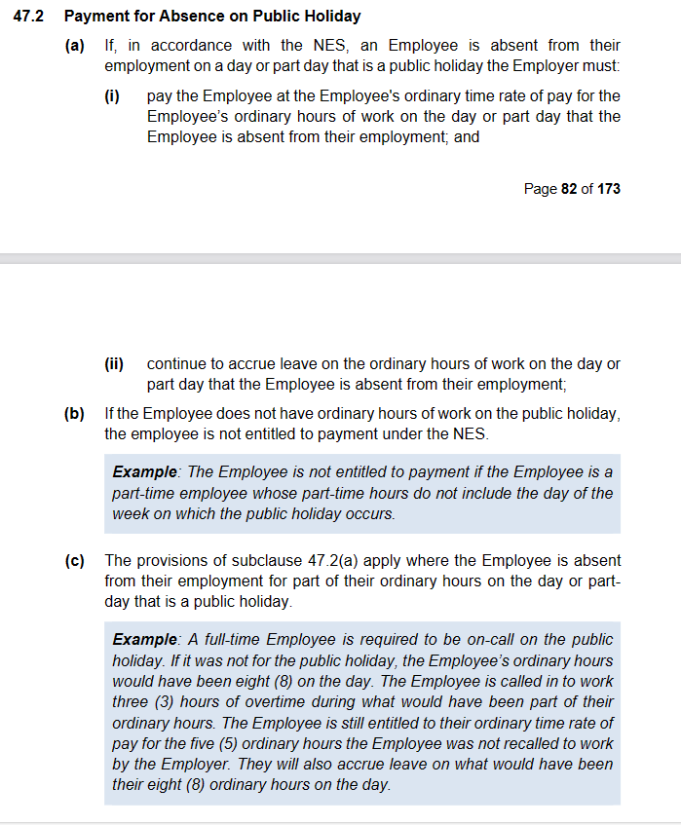
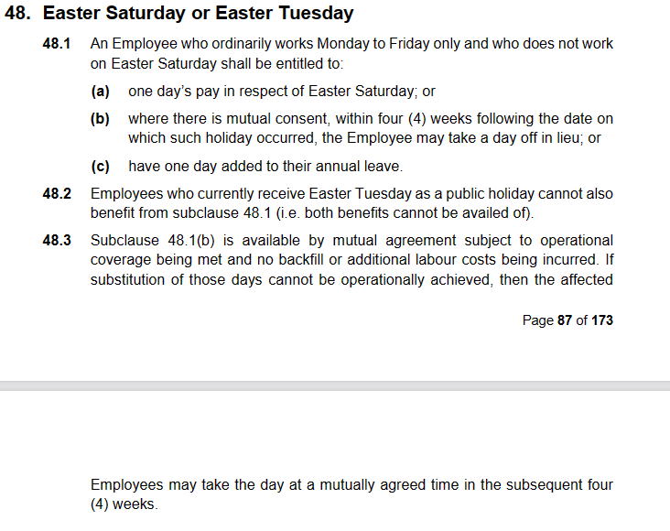

additional rules – public holidays falling on weekend
Relevant Clause
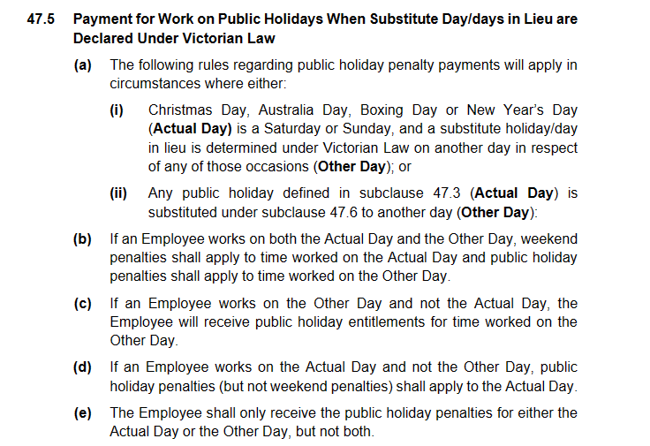

additional rules – other leave on public holidays
Leave Type | Impact of taking leave on a Public Holiday
Annual Leave | Where a public holiday occurs during a period when an Employee is on annual leave, the Employee is taken not to be on annual leave on that public holiday– see sub-clause 49.4
Personal Leave | If the period during which an Employee takes paid personal leave includes a day or part day that is a public holiday in the place where the Employee is based for work purposes, the Employee is taken not to be on paid personal leave on that public holiday – see sub-clause 51.7
Long Service Leave | Any long service leave shall be inclusive of any public holiday occurring during the period when the leave is taken -see sub-clause 60.4
Paid Parental Leave | An Employee on Paid Parental Leave when a public holiday occurs does not receive a public holiday entitlement, nor does it extend the Paid Parental Leave period
Unpaid Leave | If an employee is on Unpaid Leave when a Public Holiday occurs, the employee does not receive a public holiday entitlement.

Table 1: Summary of Public Holiday Entitlements

Full Time | Entitlement for Plumbing and Joinery and Building Trades Products Industry | Entitlement for Metal Industry | Clause Ref.
Rostered to Work (works on public holiday) | 250% (minimum 4 hours pay) | 250% (minimum 3 hours pay) | 47.7 and 47.8
Rostered to Work (not required to work) | 1 days ordinary pay at the rostered hours for that day | 1 days ordinary pay at the rostered hours for that day | 47.2
Not Rostered to Work (rostered day off or other day off) | General rule - No rostered off entitlement.  Easter Saturday: employees who do not work Easter Saturday but ordinarily work Monday to Friday will be entitled to 1 day’s ordinary pay (7.6 hours unless the employee ordinarily works longer shifts) or 1 day off in lieu within four weeks of the public holiday (by mutual agreement) or 1 day added to A/L balance.  This does not apply to employees who currently receive Easter Tuesday as a public holiday)  Seven-day Shift Workers  A seven-day shift worker, that is a shift worker who is rostered to work regularly on Sundays and holidays, when their rostered day off falls on a public holiday prescribed in this clause shall at the discretion of the Employer, be paid for that day at the ordinary rate or have an additional day added to their annual leave. This clause shall not apply when the holiday on which they are rostered off falls on a Saturday or Sunday | General rule - No rostered off entitlement.  Easter Saturday: employees who do not work Easter Saturday but ordinarily work Monday to Friday will be entitled to 1 day’s ordinary pay (7.6 hours unless the employee ordinarily works longer shifts) or 1 day off in lieu within four weeks of the public holiday (by mutual agreement) or 1 day added to A/L balance.  This does not apply to employees who currently receive Easter Tuesday as a public holiday)  Seven-day Shift Workers  A seven-day shift worker, that is a shift worker who is rostered to work regularly on Sundays and holidays, when their rostered day off falls on a public holiday prescribed in this clause shall at the discretion of the Employer, be paid for that day at the ordinary rate or have an additional day added to their annual leave. This clause shall not apply when the holiday on which they are rostered off falls on a Saturday or Sunday | 47.2 , 47.11, 48

Part Time | Entitlement for Plumbing and Joinery and Building Trades Products Industry | Entitlement for Metal Industry | Clause Ref.
Rostered to Work (works on public holiday) | 250% (minimum 4 hours pay) | 250% (minimum 3 hours pay) | 47.7 and 47.8
Rostered to Work (not required to work) | 1 days ordinary pay at the rostered hours for that day | 1 days ordinary pay at the rostered hours for that day | 47.2
Not Rostered to Work (rostered day off or other day off) | General rule - No rostered off entitlement.  Easter Saturday: employees who do not work Easter Saturday but ordinarily work Monday to Friday will be entitled to 1 day’s ordinary pay (7.6 hours unless the employee ordinarily works longer shifts) or 1 day off in lieu within four weeks of the public holiday (by mutual agreement) or 1 day added to A/L balance.  This does not apply to employees who currently receive Easter Tuesday as a public holiday)  Seven-day Shift Workers  A seven-day shift worker, that is a shift worker who is rostered to work regularly on Sundays and holidays, when their rostered day off falls on a public holiday prescribed in this clause shall at the discretion of the Employer, be paid for that day at the ordinary rate or have an additional day added to their annual leave. This clause shall not apply when the holiday on which they are rostered off falls on a Saturday or Sunday | General rule - No rostered off entitlement.  Easter Saturday: employees who do not work Easter Saturday but ordinarily work Monday to Friday will be entitled to 1 day’s ordinary pay (7.6 hours unless the employee ordinarily works longer shifts) or 1 day off in lieu within four weeks of the public holiday (by mutual agreement) or 1 day added to A/L balance.  This does not apply to employees who currently receive Easter Tuesday as a public holiday)  Seven-day Shift Workers  A seven-day shift worker, that is a shift worker who is rostered to work regularly on Sundays and holidays, when their rostered day off falls on a public holiday prescribed in this clause shall at the discretion of the Employer, be paid for that day at the ordinary rate or have an additional day added to their annual leave. This clause shall not apply when the holiday on which they are rostered off falls on a Saturday or Sunday | 47.2 , 47.11, 48

Casual | Entitlement for Plumbing and Joinery and Building Trades Products Industry | Entitlement for Metal Industry | Clause Ref.
Rostered to Work | 275% (minimum 4 hours) | 275% (minimum 4 hours – see clause 16.3(b)) | 47.7 and 47.8
Not Rostered to Work | No rostered off entitlement. | No rostered off entitlement. | Silent

Table 2: public holidays occuring until nominal expiry date
Note: Public Holidays falling on a weekend are marked in bold

2024
New Years Day – 1 January 2024 | Australia Day – 26 January 2024
Labour Day – 11 March 2024 | Good Friday – 29 March 2024
Saturday before Easter Saturday – 30 March 2024 | Easter Sunday – 31 March 2024
Easter Monday -1 April 2024 | ANZAC Day – 25 April 2024
King’s Birthday – 10 June 2024 | Friday before AFL Grand Final – 27 September 2024
Melbourne Cup – 5 November 2024 | Christmas Day – 25 December 2024
Boxing Day – 26 December 2024
Source - Victorian public holidays 2024 | Business Victoria

2025
New Years Day – 1 January 2025 | Australia Day – 26 January 2025 (A) & 27 January 2025 (O)
Labour Day – 10 March 2025 | Good Friday – 18 April 2025
Saturday before Easter Saturday – 19 April 2025 | Easter Sunday – 20 April 2025
Easter Monday – 21 April 2025 | ANZAC Day – 25 April 2025
King’s Birthday – 9 June 2025 | Friday before AFL Grand Final – TBC
Melbourne Cup – 4 November 2025 | Christmas Day – 25 December 2025
Boxing Day – 26 December 2025
Source: Victorian public holidays 2025 | Business Victoria

2026
New Years Day – 1 January 2026 | Australia Day – 26 January 2026
Labour Day – 9 March 2026 | Good Friday – 3 April 2026
Saturday before Easter Saturday – 4 April 2026 | Easter Sunday – 5 April 2026
Easter Monday - 6 April 2026 | ANZAC Day – 25 April 2026
King’s Birthday – 8 June 2026 | Friday before AFL Grand Final – TBC
Melbourne Cup – 3 November 2026 | Christmas Day – 25 December 2026
Boxing Day – 26 December 2026

Source: Victoria Public Holidays 2026 - PublicHolidays.com.au

2027
New Years Day – 1 January 2027 | Australia Day – 26 January 2027
Labour Day – 8 March 2027 | Good Friday – 26 March 2027
Saturday before Easter Saturday – 27 March 2027 | Easter Sunday – 28 March 2027
Easter Monday – 29 March 2027 | ANZAC Day – 25 April 2027
King’s Birthday – 14 June 2027 | Friday before AFL Grand Final – TBC

Melbourne Cup Day is a public holiday across all of Victoria unless alternate local holiday has been arranged by a non-metro council.
ANZAC Day is commemorated on the day it falls. There is no replacement holiday when ANZAC Day falls on a weekend

