Public holiday Guide
  - HEALTH & ALLIED SERVICES, MANAGERS & ADMINistrative WORKERS

  - victorian hospital's industrial association – Feb 2024

introduction
The purpose of this Public Holiday Guide is to replace the previous Public Holiday Matrices and summarise the public holiday entitlements afforded to employees under the Health and Allied Services, Managers and Administrative Workers (Victorian Public Sector) (Single Interest Employers) Enterprise Agreement 2021-2025. (Agreement) for the remaining life of the Agreement until it is replaced.
Members will no longer receive multiple Public Holiday Matrices throughout the year, rather members can use this document to prepare for all public holidays for the remaining life of the Agreement.
VHIA has detailed the known public holidays that occur between the publication date of this Public Holiday and the nominal expiry date of the Agreement, 30 June 2025. VHIA will provide updated advice to members closer to that date where the Agreement is anticipated to operate beyond the nominal expiry date.
It is not intended to replace the Agreement or provide an entitlement beyond the Agreement itself.
VHIA encourages members to read the relevant terms of the Agreement alongside this Public Holiday Matrix.

where to find copies of the agreement and other material
VHIA members can access copies of the Agreement and other material (such as Implementation Guides and Salary Circulars) by selecting Health and Allied Services, Managers and Administrative Workers under ‘My Professions’ on your VHIA Website Dashboard.
For more information about accessing the VHIA Website, please contact vhia@vhia.com.au

WHO TO CONTACT FOR MORE INFORMATION
Members are encouraged to direct any queries in relation to this Public Holiday Guide to query@vhia.com.au

working on a public holiday
Relevant Clause
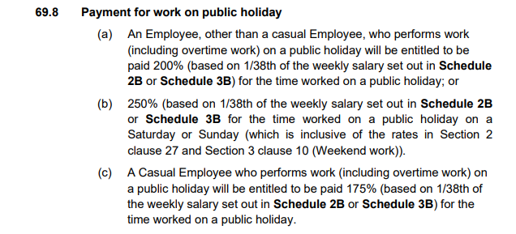

not working on a public holiday (full time & part time)
Relevant Clause
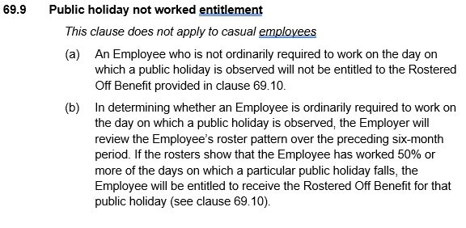

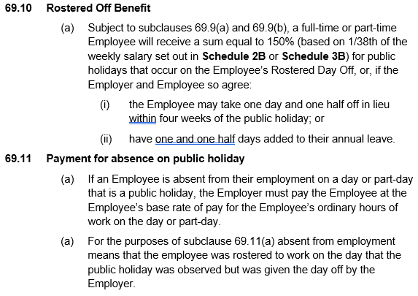

additional rules – public holidays falling on weekend
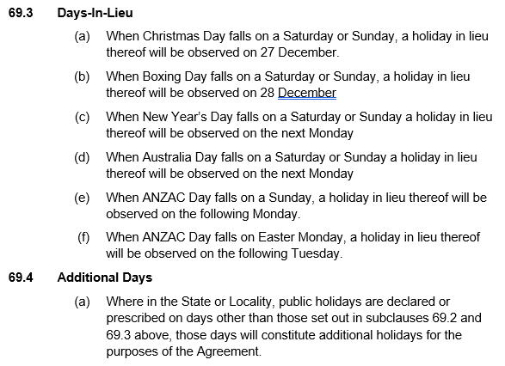
Health and Allied Services, Managers and Administrative Workers receive Public Holiday entitlements on both the Actual Day and Other Day where a Public Holiday falls on a weekend and a day in lieu (clause 69.3) or additional day (clause 69.4) is recognised – see Table 1 for more information.

additional rules – other leave on public holidays
Leave Type | Impact of taking leave on a Public Holiday
Annual Leave | Where a public holiday occurs during a period when an Employee is on annual leave, the Employee is taken not to be on annual leave on that public holiday – see sub-clause 53.5(b)
Personal Leave | If the period during which an Employee takes paid personal leave includes a day or part day that is a public holiday in the place where the Employee is based for work purposes, the Employee is taken not to be on paid personal leave on that public holiday – see sub-clause 55.5
Long Service Leave | Long service leave is inclusive of any public holiday or ADO occurring during the period when leave is taken – see sub-clause 61.2 (e)
Paid Parental Leave | An Employee on Paid Parental Leave when a public holiday occurs does not receive a public holiday entitlement, nor does it extend the Paid Parental Leave period
Unpaid Leave | If an employee is on Unpaid Leave when a Public Holiday occurs, the employee does not receive a public holiday entitlement.

Table 1: Summary of Public Holiday Entitlements

Full Time | Entitlement | Clause Ref.
Rostered to Work (works on public holiday) | 200% or 250% if it falls on a Saturday or Sunday | 69.8(a) and (b)
Rostered to Work (not required to work) | 1 days Ordinary Pay based on the hours the employee was rostered to work | 69.11
Not Rostered to Work (rostered day off) | Weekdays & Weekend PH (including Easter Saturday)  150% or the employee may take 1.5 days off in lieu (within four weeks of the public holiday) or 1.5 days added to A/L balance.  Note, this will only apply to employees who are ordinarily required to work on the day which the public holiday was observed. This is determined by reviewing the preceding 6 month roster, if an employee has worked 50% or more of the days on which a particular Public Holiday falls, the employee shall be entitled to receive the "rostered off" benefit for that Public Holiday)  An employee who is not ordinarily required to work on the day on which a public holiday is observed will not be entitled to the Rostered Off Benefit) | 69.10  69.9(b)  69.9(a)

Part Time | Entitlement | Clause Ref.
Rostered to Work (works on public holiday) | 200% or 250% if it falls on a Saturday or Sunday | 69.8(a) and (b)
Rostered to Work (not required to work) | 1 days Ordinary Pay based on the hours the employee was rostered to work | 69.11
Not Rostered to Work (rostered day off) | Weekdays & Weekend PH (including Easter Saturday)  150% or the employee may take 1.5 days off in lieu (within four weeks of the public holiday) or 1.5 days added to A/L balance.  Note, this will only apply to employees who are ordinarily required to work on the day which the public holiday was observed. This is determined by reviewing the preceding 6 month roster, if an employee has worked 50% or more of the days on which a particular Public Holiday falls, the employee shall be entitled to receive the "rostered off" benefit for that Public Holiday)  An employee who is not ordinarily required to work on the day on which a public holiday is observed will not be entitled to the Rostered Off Benefit) | 69.10  69.9(b)  69.9(a)

Casual | Entitlement | Clause Ref.
Rostered to Work (works on public holiday) | 175% for all work done (including Saturday or Sunday and overtime work) | 69.8(c)
Rostered to Work (not required to work) | 1 days Ordinary Pay based on the hours the employee was rostered to work | 69.11
Not Rostered to Work | No rostered off benefit unless they are required to work on that day | 69.9 and 69.10

Table 2: public holidays occuring until nominal expiry date
Note: Public Holidays falling on a weekend are marked in bold
2024
New Years Day – 1 January 2024 | Australia Day – 26 January 2024
Labour Day – 11 March 2024 | Good Friday – 29 March 2024
Saturday before Easter Saturday – 30 March 2024 | Easter Sunday – 31 March 2024
Easter Monday -1 April 2024 | ANZAC Day – 25 April 2024
King’s Birthday – 10 June 2024 | Friday before AFL Grand Final – 27 September 2024
Melbourne Cup – 5 November 2024 | Christmas Day – 25 December 2024
Boxing Day – 26 December 2024
Source - Victorian public holidays 2024 | Business Victoria
2025
New Years Day – 1 January 2025 | Australia Day – 26 January 2025 (A) & 27 January 2025 (O)
Labour Day – 10 March 2025 | Good Friday – 18 April 2025
Saturday before Easter Saturday – 19 April 2025 | Easter Sunday – 20 April 2025
Easter Monday – 21 April 2025 | ANZAC Day – 25 April 2025
King’s Birthday – 9 June 2025 | Friday before AFL Grand Final – TBC
Melbourne Cup – 4 November 2025 | Christmas Day – 25 December 2025
Boxing Day – 26 December 2025
Source: Victorian public holidays 2025 | Business Victoria

Melbourne Cup Day is a public holiday across all of Victoria unless alternate local holiday has been arranged by a non-metro council.

