GENERAL PRACTITIONER REFERRAL TO NEUROSURGERY SPECIALIST CLINIC
BACK AND NECK SUPPORTING CLINICAL INFORMATION FORM

PATIENT INFORMATION
Western health ur (if known):
Title First name: Surname:
Sex DOB:

Address:

Contact numbers—home: mobile:
Interpreter required: yes/no:
Preferred Language:
REFERRER DETAILS
Name:
Clinic name
Address:
Phone:
Fax:
Provider number

INDICATE AREA(S) OF SYMPTOMS PRIORITY SIGNS OF NEUROLOGICAL SYMPTOMS
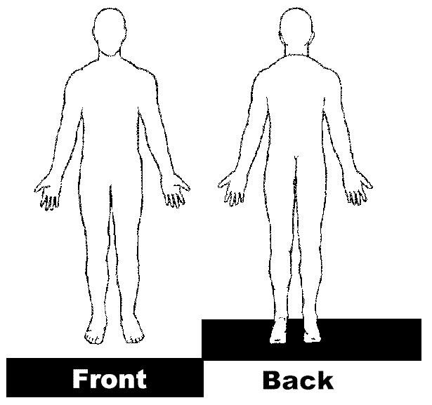
1 | WEAKNESS  If yes, list weak muscle groups | Yes | No
2 | SENSORY LOSS | Yes | No
3 | URINARY/BOWEL DYSFUNCTION PERIANAL SENSORY LOSS | Yes | No
4 | LOSS OF REFLEX  If yes, which reflex | Yes | No
5 | HYPER-REFLEXIA | Yes | No
6 | ATAXIA | Yes | No
7 | PLANTAR REFLEX | Yes | No
8 | CLONUS | Yes | No

Many types of low back/leg pain and neck/arm pain will respond to a range of CONSERVATIVE treatments. In order to prevent acute pain becoming chronic, these conservative options should be explored first unless the involvement of neurological signs is more profound.

THE EXPECTATION IS THAT TREATMENTS HAVE BEEN TRIALLED AS PART OF THE MANAGEMENT HISTORY

Treatments have been trialled as part of management history
Exercise |  | Yes/Time |  |  |  | No
Physiotherapy |  | Yes/Time |  |  |  | No
Weight loss |  | Yes/Time |  |  |  | No
Anti-inflammatory medication |  | If yes, Name & timeframe |  |  |  | No
Other |  | Please specify
Functional limitation (closest response)
Walking |  |  | <50m | 50-100m | >500m
Sitting duration |  |  | <5 mins | 5-15 mins | >15 mins
Sleep significantly disturbed |  |  |  | Yes | No
BMI

PLEASE BE AWARE THAT 90-95% OF REFERRALS TO NEUROSURGERY DO NOT REQUIRE SURGICAL INTERVENTION. NEUROSURGERY SPECIALTY IS A SURGICAL CLINIC

HISTORY OF CURRENT CONDITION (ALSO ATTACH REFERRAL LETTER)
Date of onset
Pain duration (include pain score: Visual Analogue Scale 0 – 10)

Radicular arm/leg pain

Neurological involvement

Current medication

Current/Previous management for this condition

